**CHAPTER TWO**

**LITERATURE REVIEW**

1. **Introduction**

This chapter introduces the reader to a review of what other researchers have done in the space of Global Positioning System, Global System for Mobile communication and Vehicle tracking in general. It gives a history behind these technologies and highlights the main technologies and some architectures proposed by researchers and looks into existing tracking systems. All these reviews will enlighten the reader and prepare them to better appreciate the field under study.

* 1. **Vehicle Tracking System**

Vehicle tracking systems provides security protection for fleet management solutions via GSM, GPS and GPRS technologies to track and monitor assets in motion within any geographical location. Vehicle Tracking Systems (VTSs) provides solutions within the space of fleet management, near accurate information, security and safety of assets and parking lot control. VTSs combines both hardware and software solutions such as microcontrollers, GSM and GPS modules and open and commercial software packages like google maps and open street map to track assets and provide first-hand information regarding the state of the tracked assets (Khabir Masum, 2017).

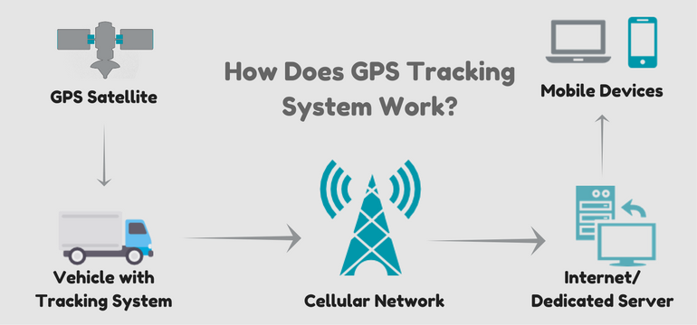

Figure 2.1 Sample Vehicle Tracking System Design

* + 1. **Types of Tracking Systems**

Basically Vehicle Tracking Systems comes under two major categories namely passive and active VTS. Passive VTSs keeps tracks of various location the asset passes and records these locations in a black-box like device which can be retrieved with a computer function when the asset gets to its final destination. Active VTSs on the other hand also keeps track of the various path of checkpoints of the assets journey but has the capability of reporting these information to central administration on real time (Jethwa et al., 2015).

* + 1. **Typical Architecture**

For any typical VTS there are some basic components that should be present for the system to work to maximum. These parts are; GPS tracking device, GPS tracking server and the user interface (UI). The tracking device is kept inside the asset in motion and transmits the required data periodically to a centralized server which receives data from the GPS tracking device, stores the data in a database for onward transmission upon the user or administrators request. The UI is basically the console from which administrator or user interacts and reads data from (Hazza Alshamisi, 2017).

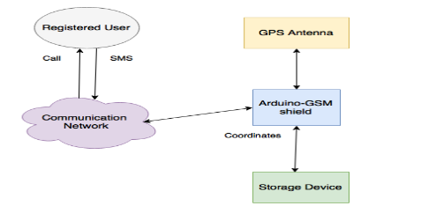

Figure 2.2: Architecture of GPS Tracking System

* + 1. **Uses of Vehicle Tracking System**

Vehicle Tracking Systems can be used in different ways to benefit individuals, businesses and societies as a whole. The initial implementation of VTSs was within the military but within the scope of time, GPS Vehicle Tracking System have found several uses and application within several fields such as fleet management, asset tracking, field service management, field sales, trailer tracking surveillance, driver behavior within the Oil and Gas industry. The technology is also applicable in anti-hijack and vehicle security systems, adventure travelling and among others (Brian, 2014).

* 1. **Global Positioning System (GPS)**

Global Position System is a satellite navigation system consisting of over 24 active satellites within space and accessible or trackable from anywhere on the surface of the earth. This ability to be accessed from anywhere creates the opportunity for devices to be link tracked from anywhere through these satellites. The concept has been implemented in different fields but its inception began from the United State military and has found its way into several fields in academia, general public and military. The next section of this chapter will expose more about the history of Global Positioning System (GPS)

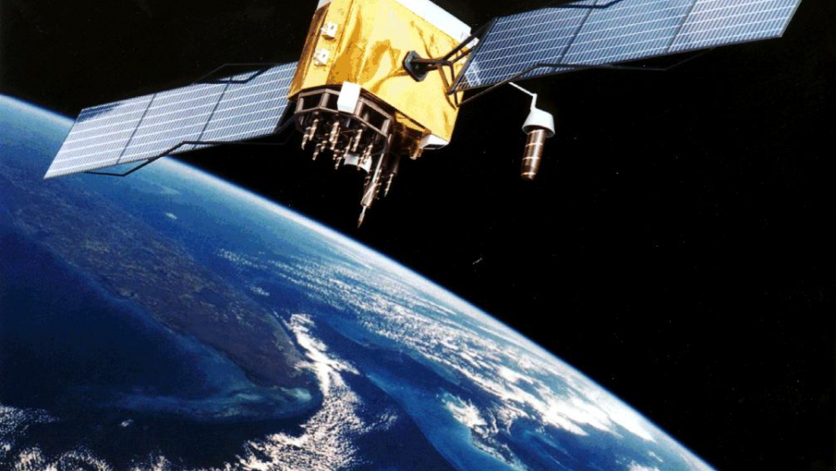

Figure 2.3 Conception of GPS block in earth orbit

* + 1. **History of Global Positioning System (GPS)**

Global Position System simply termed GPS is a technology invented by the United State Government and military and was initially referred to as Navstar GPS. The technology originated in the era of Sputnik where scientists and researchers tracked satellites with radio signal shifts known as Doppler Effect. GPS as at now has thirty-three (33) satellites with thirty-one (31) of them in Orbit. GPS has orbital height of 20,180 KM with accuracy of 5 meters. The technology was first launched about 40years ago around February 1978 and operated by Air Force Space Command (AFSC). It was not until early 70s that the military started to use it but research around this technology dates back as far as the 60s. The whole idea around GPS dates back as far as the 1957 when the United States planned and developed a sort of ground-based radio network for navigating around Russia’s artificial satellite Sputnik.

As early as 1960 there was already a satellite in motion called TRANSIT with less advancement like todays satellites. Satellites were used by the military around the 80s but GPS got into the public domain around 2000 which had refined precision as compared to the earlier inventions. As GPS became publicly available, the technology was then integrated into cell phones with the Befefon Esc been the first mobile phone to first have GPS built in it.

GPS integration in automobiles was first introduced by Toyota in 1991 in their Toyota Soarer model after which the likes of Mitsubishi followed. Today many vehicles come with GPS integration especially saloon cars.

* + 1. **Basic concepts of Global Positioning System (GPS)**

GPS consists of three segments namely; Space Segment, Control Segment and User Segment. The space segment is made up of the 24 satellite units that orbits the earth and broadcasting signals to receivers from the earth. Each of the 24 satellites makes exactly two complete orbits within a day. The control segment also referred to as the monitor station has 5 monitor control around the world which maintains accuracy of the entire system and is controlled by United State Air Force. Finally the user segment comprises users from the US military and millions of end users of which any of todays’ smart phone users are all part. GPS satellites are powered by solar energy with enough backup batteries to suffice them in the periods of solar eclipse. Through triangulation calculations, objects are located at their precise position in the realm of longitude and latitudes of the earth.

* 1. **Global System for Mobile Communication (GSM)**
     1. **History of GSM**

GSM means Global System for Mobile communication and is a standard designed and developed and first implemented in Finland in the year 1991 by European Telecommunication Standard Institute. It is widely deployed in Europe and other parts of the world providing digital telephony system using time division multiple access. GSM is a second-generation (2G) standard. The technology trace its roots in the mid-70s when Henry Kieffer in Swiss PTT proposed to Europe their need for a 900 MHz spectrum for mobile devices. Hence GSM became a hot topic for most European Research and Design Laboratories.

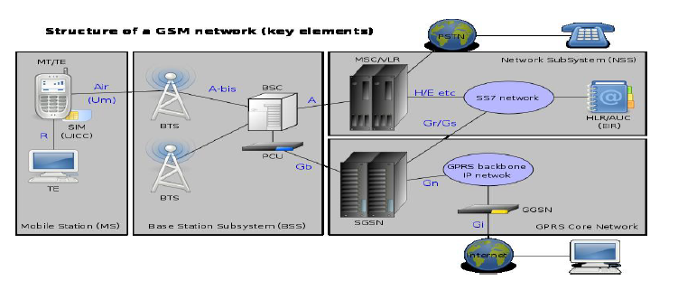

Figure The Structure of GSM Network Source: (GSMHistory, 2015)

GSM is referred to as the first ever digital systems for mobile telephony and was introduced by European Telecommunications Standard Institute (ETSI). Every GSM setup has three major subgroups thus, Mobile Station (MS), Base Station Subsystem (BSS) and Network Subsystem (NSS). The MS has a mobile equipment and a subscriber identity module (SIM) that aids mobility of the device and assigns a unique identifier to the device. The Base Station controller is made up of a Base Transceiver Station (BTS) and Base Station Controller (BSC). The Network Subsystem also comprises a Mobile Switching Center (MSC) and Gateway Mobile Switching Center (GMSC). Aside these major subgroups there are also other units like HLR, VLR, AuC and EIR.

* 1. **Subscriber Identity Module (SIM)**

SIM is an important component within GSM networks in that it is an Integrated Circuit (IC) for keeping IMSI with its related key issued for subscriber identification.

* 1. **Review of Related Literature**

Vehicle tracking innovation or technology enables us to see our vehicles areas, speed of the vehicle and different highlights on the PC screen with an assistance of GPS (Global Positioning System) innovation, GSM organize, computerized mapping and concentrated following programming. The GPS satellites transmit data like longitude, scope, elevation, Universal time and so on to the GPS beneficiary. For estimation of this data, no less than three GPS satellites are required. Yet, principle weakness of GPS is that it require coordinate viewable pathway. Its precision endures at indoor areas. Once the collector knows its position (just scope and longitude not think about height) it is put away in the microcontroller's memory put in the vehicle. After predefined interim (in this paper interval=15sec), most recent area of vehicle is sent to remote area utilizing GSM arrange. At remote area, PC gets this data and set on GOOGLE outline web get to though in our guide web get to doesn't require. Before the GSM organize set up, we can get constant following utilizing the satellite, which was exceptionally costly. Advances Involved:

* GPS – Global Positioning System
* GSM – Global System of Mobile
* GIS – Geographical Information framework

GIS is programming with point by point maps of the each place's with longitude and scope used to find the address of a vehicle fitted with GPS framework. With legitimate GIS, we get correct or close-by area of the vehicle (D, 2014).

Currently, mostly the existent tracking systems use techniques of virtual fence known as Geofence which compares the entity position with a predetermined zone or a point of interest, checking if the entity is inside or outside an area. Those techniques do not allow full coverage of the course, making difficult to determine if a truck or another delivery vehicle is travelling in a planned path. Therefore, we need to use an alternative technique that allows continuous monitoring of travels, obtaining information of probable deviations or even emergency situations (Dhumal, Naikoji, Patwa, & Shilimkar, 2015).

A Vehicle Tracking System(VTS) framework consolidates the establishment of an electronic gadget in a vehicle, or armada of vehicles, with purposed-outlined computer program to empower the proprietor or an administrator to track the vehicle's area, gathering information all the while. Present day vehicle following frameworks normally utilize Global Positioning System (GPS) innovation for finding the vehicle, however different kinds of programmed vehicle area innovation can likewise be utilized. GSM and GPS based vehicle area and following framework will give compelling, constant vehicle area, mapping and announcing this data esteem and promotions by enhancing the level of administration gave. A GPS-based vehicle following framework will educate where your vehicle is and where it has been, to what extent it has been. The framework utilizes geographic position and time data from the Global Positioning Satellites. Vehicle data can be seen on electronic maps by means of the Internet or particular programming. Existing System: In the past framework just scope and longitudes are accessible. In the proposed framework, a GPRS module is utilized to find the place and send instant message. This GPS will be area the situation of vehicle and transmit that information to the microcontroller. Recipient unit send the flag to the microcontroller, from that we can distinguish the burglary. On the off chance that the vehicle is robbery it consequently sends area of the vehicle to its proprietor as a SMS through GSM modem. This will be a substantially less difficult and minimal effort method contrasted with others. The event of mishap is very unavoidable. The proposed technique is challengingly embraced to roll out the improvements in most exceedingly awful situation by giving the required alerts and fundamental data to the close-by crisis focuses. It additionally screens and tracks the area where crisis (Srikanth, Prasad, Venugopal, Rohith, & Sridhar, 2016).

Lahire narrates that commercial fleet operations are currently the largest users of VTSs for tracking operational functions in the space of path routes, security and dispatch and onward collection of data. The technology is also used for fire detection most especially in the space of long vehicles like buses, coaches and trains to save lives. The technology can also deploy several other sensors to server specific purposes under different conditions. The microcontroller used in this research project have inbuilt ADCs and hence the controller is capable of accepting analog inputs, providing an upper hand advantage over other modules. Since all real world signals are analog in nature, by incorporating different sensors required purpose can be served (Lahire, 2017).

Abinaya et al (2014) proposed a novel method of vehicle tracking and locking systems used to track the theft vehicle by using GPS and GSM technology. This system puts into the sleeping mode vehicle handled by the owner or authorized persons; otherwise goes to active mode. The mode of operations changed by persons or remotely. When the theft identified, the responsible people send SMS to the micro controller, then issue the control signals to stop the engine motor. After that all the doors locked. To open the doors or to restart the engine authorized person needs to enter the passwords. In this method, easily track the vehicle place and doors locked. Their research work seeks to prevent accidents through deploying eye blink sensor which reads the drivers blinks and upon certification of tiredness, pulls back the vehicle from moving further. Through the deployment of GPS and GSM technologies there is a higher provision of driver security which goes a long way to prevent accidents. Beyond these the model is able to detect obstacles within lanes which supports efficient parking for vehicles (Abinaya & Devi, 2014).

GSM modem does not support all the mobile phone network. Better to know which mobile network supports the GSM modem. For this project, used GSM modem only support O2 and Orange. Orange mobile network has been used. GPS modem provides data continuously but it is observed that when GPS position is changed it takes some time to give current location data. When GPS is connected to a new location, first it provides the information of the previous location and few minutes later it provides current position information. This can be confusing (Khabir Masum, 2017).

According to Akshatha (2007), tracking systems keeps a check on the moving objects. In his research he stated that public transportation systems in India especially are prone to various crimes and social vices and therefore needs monitoring. He proposed a sort of surveillance system that provides 24 hour security through the use of GPS technologies. The study proposed a sort of GPS receiver mounted in transport vehicles for monitoring and tracking of public vehicles against crimes (Akshatha, 2017).

Hasan et al, (2009) proposed a cost effective GPS-GPRS based object tracking system that gives users the ability to view past and present location of the tracked object through the internet via Google maps. The model tracks with the GPS model and sends the coordinates via GPRS from the nearest GSM network available. Their proposed solution comes with a web interface developed with PHP, JavaScript, Ajax and MySQL. The recorded dataset of the location is forwarded to database through POST method with HTTP protocol. Their system deployed makes use of GPRS which is less expensive as compared to the popular SMS module. Their module is influenced by the problem associated with car theft and tracking of adolescent drivers (Hasan, Rahman, & Haque, 2009).

Tracking modules are getting the chance to be continuously imperative in far reaching urban territories and it is more anchored than various systems. It has ceaseless capacity, ascends with a particular true objective to invigorate the relations among people, vehicle and road by amassing present day information advances or innovations and prepared to structures an ongoing exact, convincing comprehensive transportation system. Refreshing this setup is basic which makes it open to future an essential which in like manner makes it more proficient. The proposed work this author is financially savvy, solid and has the capacity of forestalling robbery and giving exact tracking framework. A keen enemy of robbery framework is one of the basic frameworks that homogenise the two GPS and GSM frameworks. It is essential in light of the immense quantities of employments of both GSM and GPS structures and the wide utilisation of them by a large number of people all through the world. This system planned for customers in zone advancement and transport business, gives ongoing data, for example, area, speed and expected landing time of the client is moving vehicles in a brief and simple to-peruse arrange. This system may moreover significant for correspondence process among the two core interests (Singh, Sethi, Biswal, & Pattanayak, 2015).

Tracking systems are no new modules today as their deployments are seen with fleet management companies, public institutions and individuals because they are seen to be secured and help track the behavior of people. The ability to track assets from anywhere on real time with accurate and more precise geo-location readings remains the major reasons for implementation of these frameworks (Harshadbhai, 2013).

The vehicle following framework introduced by Mukhtar (2015) can be utilized for situating and exploring the vehicle with a precision of 10 m. The situating is done as scope and longitude alongside the correct area of the place, by making utilization of Google maps. The framework tracks the area of a specific vehicle on the user‟s demand and reacts to the client by means of SMS. The got SMS contains longitude and scope that is utilized to find the vehicle on the Google maps. This framework enables a client to: remotely switch ON the vehicle‟s start framework, remotely turn OFF the vehicle‟s start framework, remotely bolt the entryways of the vehicle, remotely open the entryways of the vehicle, and remotely track a vehicle‟s area. A few changes were rolled out in which most eminent improvement was adjustment of the following philosophy (i.e. Access to 32 stations of satellites rather than 3). The vehicle following framework was constructed effectively. Be that as it may, the framework could be made more powerful by utilizing more precise GPS unit (Mukhtar, 2015).

Abinaya et al (2014) narrates that over the most recent couple of decades, India has advanced at such a gigantic rate, to the point that numerous organizations have unequivocally settled themselves here. These organizations carry an enormous measure of workforce with them. Organizing transportation to such an enormous mass is a bulky assignment including numerous complexities. By and large, vehicles are organized through the nearby transport merchants on a yearly contract premise, as of late happen setbacks, for example, thievery, assault cases and so forth. The improvement of satellite correspondence innovation is anything but difficult to recognize the vehicle areas. Vehicle tracking systems (VTS) frameworks have conveyed this innovation to the everyday existence of the regular individual. Today GPS utilized in autos, ambulances, armadas and police vehicles are basic sights on the streets of created nations. All the current innovation bolster following the vehicle place and status. The GPS/GSM Based System is a standout amongst the most critical frameworks, which incorporate both GSM and GPS advancements. It is fundamental due to the a large number of uses of both GSM and GPS frameworks and the wide utilization of them by many individuals throughout the world. This framework intended for clients in arrive development and transport business, gives constant data, for example, area, speed and expected entry time of the client is moving vehicles in a brief and simple to-peruse arrange. This framework may likewise be helpful for correspondence process among the two focuses (Abinaya & Devi, 2014).

Hazza explain in his research paper that vehicle track framework are innovation used to decide the area of a vehicle utilizing GPS and such this innovation has turned out to be extremely conspicuous. Keeping in mind the end goal to actualize a VTS framework which can show the area on google outline, GPS, GSM/GPRS modules controlled by Arduino MEGA must be put inside the vehicle. The vehicle position will be refreshed each 10 second as the vehicle is moving. This framework empowers the proprietors who have costly autos to watch and track the vehicle and discover vehicle development and its past exercises. This innovation prominently called constant GPS vehicle Tracking Systems which made numerous miracles in the security of the vehicle. The framework can be fitted into the vehicle where it can't be seen by anyone.Thus it is utilized as a secretive unit which persistently or by any hinder to the framework, sends the area information to the observing unit. At the point when the vehicle is lost or stolen, the framework can send the area by sending the directions to the particular portable when the client makes the demand, the framework consequently sends an arrival answer to that specific versatile demonstrating the situation of the vehicle as far as scope and longitude which can be seen utilizing Google Map. This data is accessible to approved clients of the framework by means of site over the web (Hazza Alshamisi, 2017).

There are numerous vehicle following frameworks being produced in the advanced and developing economies. These installed frameworks with their variety of equipment modules have been incorporated into bunches of open and private vehicles in the urban region. A framework for following and knowing the area of between city transports in urban regions was created in Ghana by the University of Ghana. GPS and GSM/GPRS framework was utilized in the following framework which sends SMS cautions about the vehicle area and furthermore gives ongoing following through web application. To keep up the following information outer database server was utilized which again expanded the cost of the following framework. The framework additionally gave numerous different upgrades like burglary alarm etc. Tracking frameworks were first created for the delivery business to track load. First gadgets created were inactive. To get programmed and ongoing following dynamic gadgets are to be utilized. Muruganandham and P.R.Mukesh proposed a framework that usesGSM/GPRS modem and GPS framework to gave ongoing following over the web by TCP/IP association through Java applications grew particularly for it. Outer databases are utilized to keep up the following subtle elements. The Bangalore vehicle following and control frameworks at Bangalore and progressing ventures at Koyambedu, Chennai gives constant answers for open vehicles. Based on the writing surveys, the framework proposed here is a GPS/GSM constant vehicle following framework with interior database of the different area subtle elements of which the vehicle would go once a day. This arrangement can be connected to open transport transports and school transports which take just the predefined courses regularly (Joseph, Ayyappan, Aswini, & Bharathy, 2013).

Automated Vehicle Location (AVL) is a propelled strategy used to track and screen any remote vehicle outfitted with a product unit that gets and exchanges motions through GPS satellite. The outcomes exhibited in this work by Baja et al (2012) contain execution of Startup schedule, Logs of Tracking Server and Pointing out current area of vehicle. For vehicle following progressively, in-vehicle unit and a tracking server is utilized. In the event that the separation amongst vehicle and tracking server is not as much as RFID can be utilized. For more separation, GSM/GPRS modem on GSM arrange by utilizing SMS or direct TCP/IP association with tracking server through GPRS is utilized. For this, tracking server likewise has GSM/GPRS modem that gets vehicle area data by means of GSM system and stores this data in database. This data is accessible to approved clients of the framework by means of site over the web. Accordingly AVL can be utilized for both the little scale and in addition vast scale based activities and this innovation is constantly turned out to be helpful for the general public (Bajaj & Gupta, 2012).

Verma et al proposed a project which is all about controlling theft of a vehicle. The system is about making vehicle more secure by the use of GPS, GSM technology and a web application. The simulation is done by PROTEUS software. It can also be beneficial for parenting where parents can deploy this framework to look after their children. The framework could also be used to track animals in the jungle, help in delivery services and be used also in the cops department and fire services. This project can be further enhanced by the use of camera and by developing a mobile based application to get the real time view of the vehicle instead to check it on PC, which would be more convenient for the user to track the target (Verma & Bhatia, 2013).

Another research in this field by Alexe et al (2011) proposed a new tracking information system using both GSM and GPS based on cloud computing infrastructure with sensors which are are deployed for fuel level checks, driver conditions, and speed of the vehicle. Data is instantly transferred to the cloud through the GSM component and all assets with this frame work uses GPS antenna for locating the place of these assets. The proposed technology significantly avoids the accident in highways (Alexe & Ezhilarasie, 2011).

The far reaching of mobiles as handheld gadgets prompts different imaginative applications that makes utilization of their consistently expanding nearness in our every day life. One such application is zonal tracking. A study by Sahoo et al (2012) proposes a model for area following utilizing Geographical Positioning System (GPS) and Global System for Mobile Communication (GSM) innovation. The framework shows the protest moving way on the screen and a similar data can likewise be imparted to the client mobile phone, on request of the client by asking the particular data by means of SMS. This framework is extremely helpful for auto robbery circumstances, for youthful drivers being watched and checked by guardians. The outcome demonstrates that the question is being followed with an insignificant following blunder (Sahoo & Rath, 2012).

The foundations of Vehicle Tracking Systems lie in delivery or shipping industry. They required a type of framework to figure out where every vehicle was at any given time and to what extent it voyaged. At first these frameworks produced for fleet administration were inactive tracking frameworks. In inactive tracking framework an equipment gadget introduced in the vehicle store GPS area, speed, heading and a trigger occasion, for example, key on/off, entryway open/shut. At the point when vehicle comes back to a particular area, the gadget is expelled and information downloaded to PC. Continuous tracking framework was required that can transmit the gathered data about the vehicle after general interims or if nothing else could transmit the data when required by checking station. Dynamic frameworks were produced that transmit vehicle's information progressively through cell or satellite systems to a remote PC or server farm. Numerous vehicle frameworks that are being used now days are some type of Automatic Vehicle Location (AVL). It is an idea for deciding the geographic area of a vehicle and transmitting this data to a remotely found server. The area is resolved utilizing GPS and transmission system could be a satellite, earthly radio cell association from the vehicle to a radio recipient, satellite or adjacent cell tower. After catch, the following information can be transmitted utilizing any decision of telemetry or remote interchanges frameworks. GSM is the most well-known utilized administration for this reason (Kamble, 2012).

(Sutaone, Joshi, Bahirat, Nair, & Karunesh, 2014).

Bhadane et al (2015) proposed a system with tele monitoring for public transportation with cities. In their research their design came with an a mounted on-board module for tracking purposes. The module is made up of GPS, GSM and an ARM processor. The GPS broadcasts a navigation message received and resolved by GPS receiver on the vehicle terminal. The longitudes and latitudes of the GPS is calculated per the location of the vehicle with the module and messaged with the assistance of GSM controller onto a GSM network for onward communication with the administrator or user.

Tracking framework is these days the most critical framework for the individual who need their auto security in productive hands this is the fundamental motivation behind why the vehicle tracking framework are getting prominent step by step in metropolitan regions as well as in little urban communities. This framework is totally incorporated and it winds up conceivable to the client to track his auto effectively whenever and from anyplace. As the vehicle burglary is expanding step by step however because of this individuals can't abstain from purchasing vehicles yet they found an effective method to watch out for their vehicle without being near them. These frameworks can keep a decent control on the burglaries and help maintaining a strategic distance from them to some degree. Fundamentally in all these framework the GPS and GSM are utilized to track the vehicle. Utilizing this framework the client can figure out where the vehicle is, what amount has it voyage, and the separation finished by it. The client can get to the situation of his vehicle at any moment of time. This framework is dependable any exceptionally secure. Updating this setup is simple which makes it open to future necessities without the need of modifying everything starting with no outside help, which additionally makes it more effective (Bhadane, Bharati, Shukla, Wani, & Ambekar, 2015).

In automobile field, the security and theft prevention are one of the main areas in current scenario. The security goals are achieved by the GSM, GPS technology. But it is commonly used the four wheeler and not in the two wheeler. Using these technologies, we can only track and monitor the vehicle. Previously, GPS is used to get the vehicle current position of the two wheelers and that data will be send to the user mobile phone through the GSM. In this system, we implement for theft prevention in two wheeler using GSM, GPS and Android technology. We can track, monitor and stop the stolen two wheelers too by this system. The two wheeler position is obtained by the GPS module, which is send to the microcontroller, which then sends the message to the user smart phone through the GSM module. In this implementation we use Atmel microcontroller, air solenoid and water solenoid valves are interfaced with GSM modem and GPS module which will be fixed in the two wheeler. User can stop the two wheeler when the vehicle under theft by android application (Vigneshwaran, Sumithra, & Janani, 2015).

Maurya et al (2012) proposed an anti-theft system for tracking vehicles and other automobiles. Beyond vehicles, the proposed system can be use to track assets and wildlife and has future thoughts of integrating with other related devices. The system has a server for tracking router of tracked vehicles and has sensors that reports other vital information making it an intelligent sort of tracking system (Maurya, Singh, & Jain, 2012).

Smart vehicle with GSM alert system is a GPS tracking system which is required in many situations like in case of car theft detection. In an approximate survey, a huge number of vehicles are being theft in a month, and out of that, only a little number of vehicles are tracked, often in an-roadworthy conditions, with many components missing. So we decided our project on smart vehicle tracking system. In this project by Parmar et al (2015) a vehicle’s position is tracked using GPS module. Using a microcontroller and GSM, real time position of the vehicle is send to owner’s mobile. This system protects user’s vehicle from theft. In case of stolen vehicle user can shut down engine by sending command to controller. Components in this system are GPS module, Microcontroller, GSM module, Accelerometer sensors. GPS module will send coordinates to the microcontroller. Microcontroller then sends this data to the user in text message via GSM module. This text message contains longitude and latitude of the location. By this system user can get minute-by-minute updates about vehicle location. We have added an additional feature with the vehicle tracking system that is the “Accident alert system”. This system works such as airbag sensor’s which are present in vehicles named as accelerometer sensors. This sensor’s, senses sudden vibration and sends the location to the user’s family members with an alert message (Parmar, Parmar, & Rao, 2015).

**SUMMARY**

Looking through the collection of literature studied, every module seeks to address the ability to be in the know there where about of assets at any point in time with respect to satellite geo-coordinates. This in a way will help track countless number of properties; vehicles like coaches and buses, trains, wildlife, people and among others. And in most cases the implementation is done to assist shipping agencies though recent study shows deployment of these technologies in our daily lives the majority of these implementation surrounds the shipping industry.